Back End Enginnering

**Project Report Semester – V (2023)**

**Restaurant Management System**



**Supervised By: Submitted By:**

Mr. Rahul Aadi Dayal, 2310990256, G4

Abhay Sood, 2310990261, G4 Arjit Surana, 2310990295, G4 Aryan Walia, 2310990305, G4

**Department of Computer Science and Engineering Chitkara University Institute of Engineering & Technology, Chitkara University, Punjab**

# ABSTRACT

The Restaurant Reservation System is a full-stack web application that enables customers to browse restaurant information, view menus, and make table reservations while allowing restaurant administrators to manage bookings, update restaurant details, and monitor operations. Built with Node.js on the backend and React on the frontend, the system uses MongoDB as a NoSQL database for flexible data storage and scalability. The architecture follows a clean separation of concerns: React provides a responsive, component-based UI for browsing restaurants, viewing menus, and completing reservations, while Node.js exposes RESTful APIs for reservation management, restaurant information updates, menu administration, and role-based access control.

Key functionalities include customer authentication and interfaces for browsing restaurants with detailed information, viewing comprehensive menus with pricing, making table reservations with date/time selection; admin dashboards for managing reservations, updating restaurant details, menu management, and table availability control; real-time reservation status updates and confirmation systems.

The backend leverages MongoDB for flexible document-based storage, supporting complex restaurant data structures including menus, table configurations, and reservation histories. Validation is enforced at both client and server layers using form validation in React and middleware validation in Node.js, ensuring data integrity. Security is handled through JWT-based authentication, enabling distinct roles for customers and administrators, protected endpoints, and secure CORS configuration.

# TABLE OF CONTENTS

|  |  |  |
| --- | --- | --- |
| **Sr. No.** | **TITLE** | **PAGE NO.** |
| **1** | **INTRODUCTION**   * Background * Objectives * Significance * Project Scope | **1-3** |
| **2** | **PROBLEM STATEMENT AND REQUIREMENT** | **4-5** |
| **3** | **PROPOSED DESIGN AND METHODOLOGY**   * System Architecture * Design Methodology * Key Components and Feature Schematic Diagram | **6-10** |
| **4** | **RESULTS** | **11-15** |
| **5** | **REFERENCES** | **16** |

1. **INTRODUCTION**

## BACKGROUND

Managing restaurant reservations traditionally relies on phone calls, paper logs, and manual coordination between staff members. These fragmented workflows lead to problems such as double bookings, lost reservations, inefficient table management, and poor customer experience. Restaurant owners need a streamlined way to manage table availability, track reservations, and communicate with customers, while diners expect easy access to restaurant information, menus, and hassle-free booking experiences.

The Restaurant Reservation System addresses these gaps by providing a centralized, digital platform for the entire reservation lifecycle. Restaurant administrators can manage table configurations, update menus and restaurant information, and monitor reservations in real time. Customers can browse restaurant details, view current menus with pricing, and make reservations from a modern web interface, receiving immediate confirmation and updates. By replacing manual processes with a consistent, API-driven workflow, the system improves operational efficiency, reduces booking errors, and enhances the overall dining experience.

## OBJECTIVES

* + - Enable customers to browse restaurant information and make table reservations easily
    - Allow restaurant administrators to manage reservations, tables, and restaurant details
    - Provide real-time menu viewing with current pricing and availability
    - Implement secure authentication with role-based access for customers and admins
    - Create a scalable system using modern web technologies for optimal performance
    - Track reservation analytics and customer preferences for business insights

## SIGNIFICANCE

The Restaurant Reservation System is significant because it digitizes and centralizes reservation processes that are often managed through scattered phone logs and manual systems, reducing booking errors and operational overhead while improving data accuracy and security through validated inputs and role-based access. It enhances the customer experience with easy restaurant discovery, menu browsing, quick reservation booking, instant confirmations, and real-time updates about their bookings. Restaurant owners gain real-time visibility into reservation patterns, table utilization, peak hours, and customer preferences for better operational planning and revenue optimization.

Technically, the Node.js, React, MongoDB, JavaScript, HTML, and CSS stack provides rapid development capabilities with excellent scalability and flexibility. MongoDB's document-based structure perfectly accommodates complex restaurant data including nested menu categories, table configurations, and customer preferences. This modern technology foundation enables future enhancements like integration with payment systems, loyalty programs, waitlist management, and mobile applications.

.

## PROJECT SCOPE

The project will deliver a comprehensive web platform where customers can browse restaurant information including location, contact details, operating hours, and ambiance photos; view detailed menus organized by categories with descriptions and current pricing; make table reservations by selecting date, time, party size, and special preferences; and manage their booking history with modification and cancellation capabilities.

Restaurant administrators will have access to powerful management tools including reservation dashboard with real-time booking status, table management for configuring seating arrangements and availability, comprehensive menu management for updating items, prices, and categories, restaurant profile management for updating information and photos, and analytics dashboard showing reservation trends and customer insights.

The system uses Node.js with Express.js framework for robust backend API development, React with modern hooks for responsive frontend interfaces, MongoDB for flexible and scalable data storage, and implements secure JWT-based authentication with proper role separation between customers and administrators.

# PROBLEM DEFINITON AND REQUIREMENT

## PROBLEM STATEMENT

There is no unified digital platform where restaurants can efficiently manage their reservations and customers can easily browse restaurant information, view menus, and make table bookings online. This leads to inefficiencies in reservation management, customer dissatisfaction due to booking conflicts, missed revenue opportunities, and increased operational overhead for restaurant staff.

Traditional reservation systems rely heavily on phone calls and manual record-keeping, which are prone to human error, double bookings, and poor customer experience. Customers often struggle to find updated menu information, availability, and restaurant details, while restaurant owners lack real-time insights into their booking patterns and customer preferences.

This project solves these issues by providing a comprehensive online restaurant reservation system using Node.js, React, MongoDB, JavaScript, HTML, and CSS. The system enables efficient reservation management for restaurants and provides customers with seamless access to restaurant information, menus, and booking capabilities, eliminating manual processes and improving overall operational efficiency.

## SOFTWARE REQUIREMNETS

## Core Requirements

* + - **Node.js** (v14 or above) for backend server development and API creation
    - **React.js** (v17 or above) for frontend user interface development
    - **MongoDB** (v4.4 or above) for database storage and management
    - **JavaScript** (ES6+) for both frontend and backend logic implementation
    - **HTML5** for semantic markup and structure
    - **CSS3** for responsive styling and user interface design

**Supporting Software**

* **Visual Studio Code** or any preferred code editor for development
* **MongoDB Compass** for database visualization and management
* **Postman** for API testing and documentation
* **npm** (Node Package Manager) for dependency management
* **Git** for version control and collaboration

**Dependencies**

**Backend Dependencies:**

* express (web framework for Node.js)
* mongoose (MongoDB object modeling)
* jsonwebtoken (JWT authentication)
* bcryptjs (password hashing)
* cors (Cross-Origin Resource Sharing)
* dotenv (environment variable management)
* nodemon (development server auto-restart)

**Frontend Dependencies:**

* react (core React library)
* react-dom (DOM rendering for React)
* react-router-dom (client-side routing)
* axios (HTTP client for API calls)
* react-datepicker (date selection component)
* react-toastify (notification system)

# PROPOSED DESIGN AND METHODOLOGY

## SYSTEM ARCHITECTURE

* The **Frontend (React.js)**:
  + Provides responsive user interfaces for both customers and administrators
  + Communicates with backend APIs through HTTP requests using Axios
  + Handles restaurant browsing, menu viewing, reservation booking, and administration panels
  + Implements client-side routing for seamless navigation experience
  + Uses modern React hooks for state management and lifecycle handling
* **Backend (Node.js with Express.js)**:
  + Exposes comprehensive REST APIs for all system functionalities
  + Implements business logic, validation, authentication, and authorization
  + Handles reservation processing, menu management, and user operations
  + Uses middleware for security, logging, and error handling
  + Integrates with MongoDB through Mongoose ODM for data operations
* **Database (MongoDB):**
  + Stores restaurant data, user profiles, reservations, and menu information
  + Uses flexible document structure to accommodate varying restaurant configurations
  + Implements indexing for efficient querying and performance optimization
  + Supports complex queries for reservation analytics and reporting
* **Security Layer**
  + JWT-based authentication for stateless user sessions
  + Role-based access control separating customer and admin functionalities
  + Password hashing using bcrypt for secure credential storage
  + CORS configuration for safe cross-origin requests

## KEY COMPONENTS AND FEATURES

#### Key Components

#### Customer Interface

#### Restaurant Discovery: Browse restaurants with detailed information including photos, location, contact details, operating hours, and cuisine type

#### Menu Viewing: Interactive menu display with categories, item descriptions, prices, and dietary information

#### Reservation System: Intuitive booking interface with calendar selection, time slots, party size, and special requests

#### User Profile: Personal dashboard for managing profile information, reservation history, and preferences

#### Administrator Dashboard

#### Reservation Management: Comprehensive view of all bookings with status tracking, modification capabilities, and customer communication tools

#### Table Management: Configure seating arrangements, table capacities, availability schedules,

#### and special arrangements

#### Menu Administration: Full CRUD operations for menu items, categories, pricing, and availability status

#### Restaurant Profile: Update restaurant information, photos, operating hours, contact details,

#### and policies

#### Analytics Dashboard: Reservation trends, popular time slots, customer demographics, and revenue insight

## SCHEMATIC DIAGRAM

## Frontend Layer:

## Landing Page: Showcases featured restaurants, search functionality, and user registration/login access

* + Restaurant Discovery: Allows users to browse restaurants with filtering options by cuisine, location, price range, and ratings
  + Menu Viewer: Displays detailed menus with categories, descriptions, prices, and availability status
  + Reservation Interface: Provides intuitive booking forms with date/time selection, party size, and special requests
  + User Dashboard: Enables customers to manage profiles, view reservation history, and modify bookings
  + Admin Panel: Comprehensive management interface for restaurant owners and staff

**• Backend Layer:**

* Authentication Service: Handles secure user registration, login, and JWT token management
* Authentication Service: Handles secure user registration, login, and JWT token management
* Reservation Management: Processes booking requests, availability checking, and confirmation workflows
* Restaurant Management: Manages restaurant profiles, menu updates, and operational information
* User Management: Handles customer profiles, preferences, and account operations
* Analytics Service: Generates reports on reservation patterns, revenue, and customer insights
* Notification System: Manages email confirmations, SMS alerts, and in-app notifications

**• Database Layer:**

* Users: Stores customer and admin credentials, profiles, preferences, and contact information
* Restaurants: Contains comprehensive restaurant data including location, contact details, operating hours, policies, and photos
* Menus: Detailed menu structure with categories, items, descriptions, pricing, and availability
* Reservations: Complete booking records with customer details, table assignments, status, and special requests
* Tables: Table configurations, capacities, locations, and availability schedules
* Analytics: Aggregated data for business intelligence, reporting, and trend analysis
* Reviews: Customer feedback, ratings, and dining experience records

**• Integration Layer:**

* Payment Gateway: Secure payment processing for deposits and advance bookings
* Email Service: Automated confirmation emails and communication system
* SMS Gateway: Text message notifications for booking confirmations and reminders
* Maps Integration: Location services and directions for restaurant discovery

# RESULTS

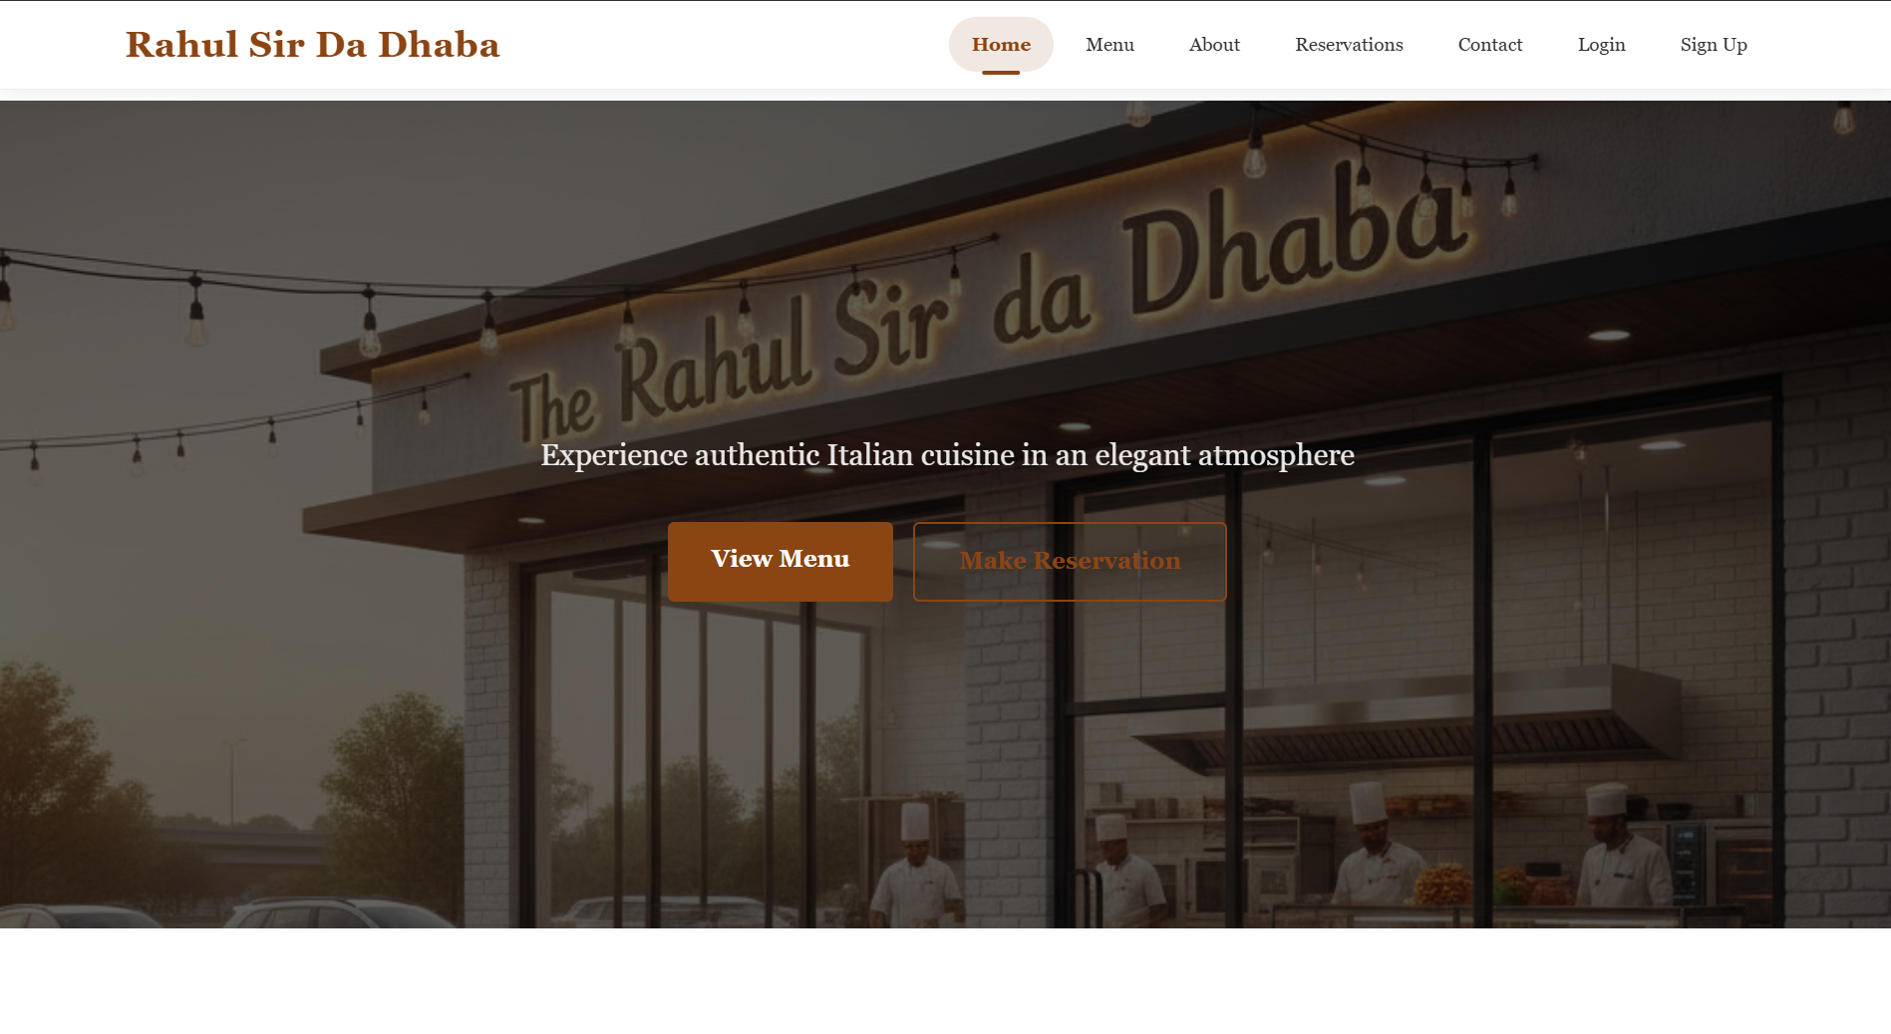

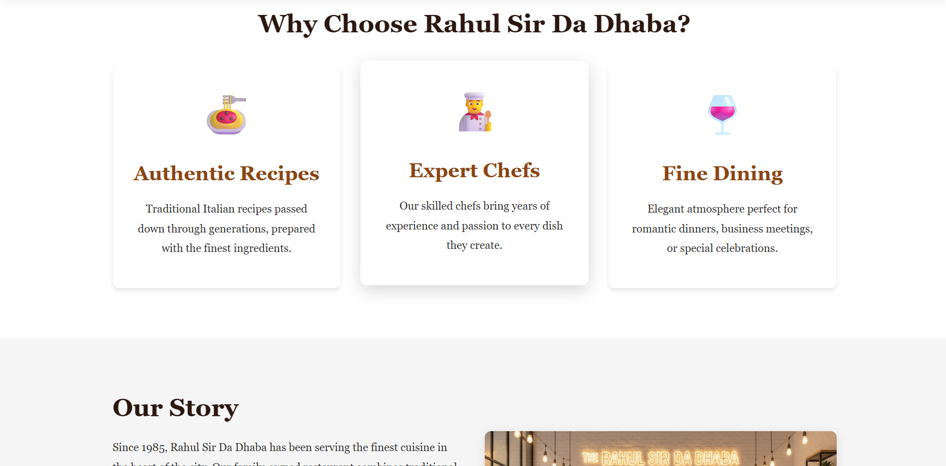

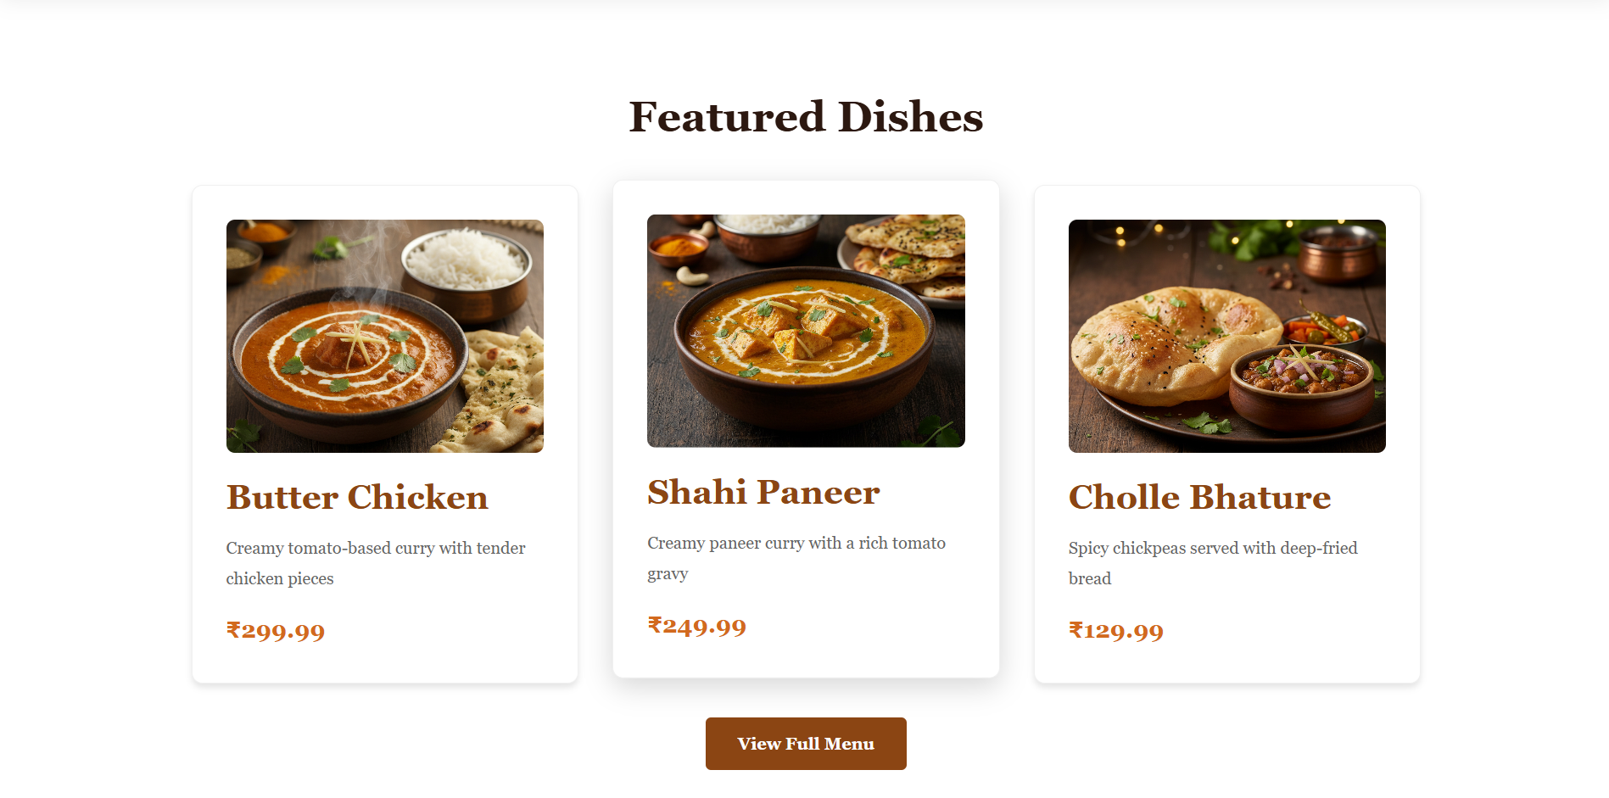

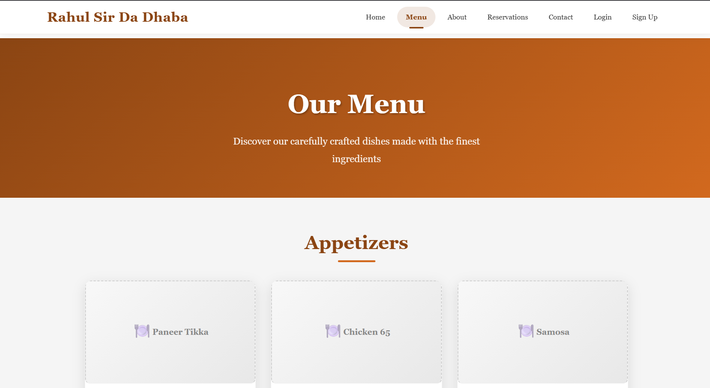

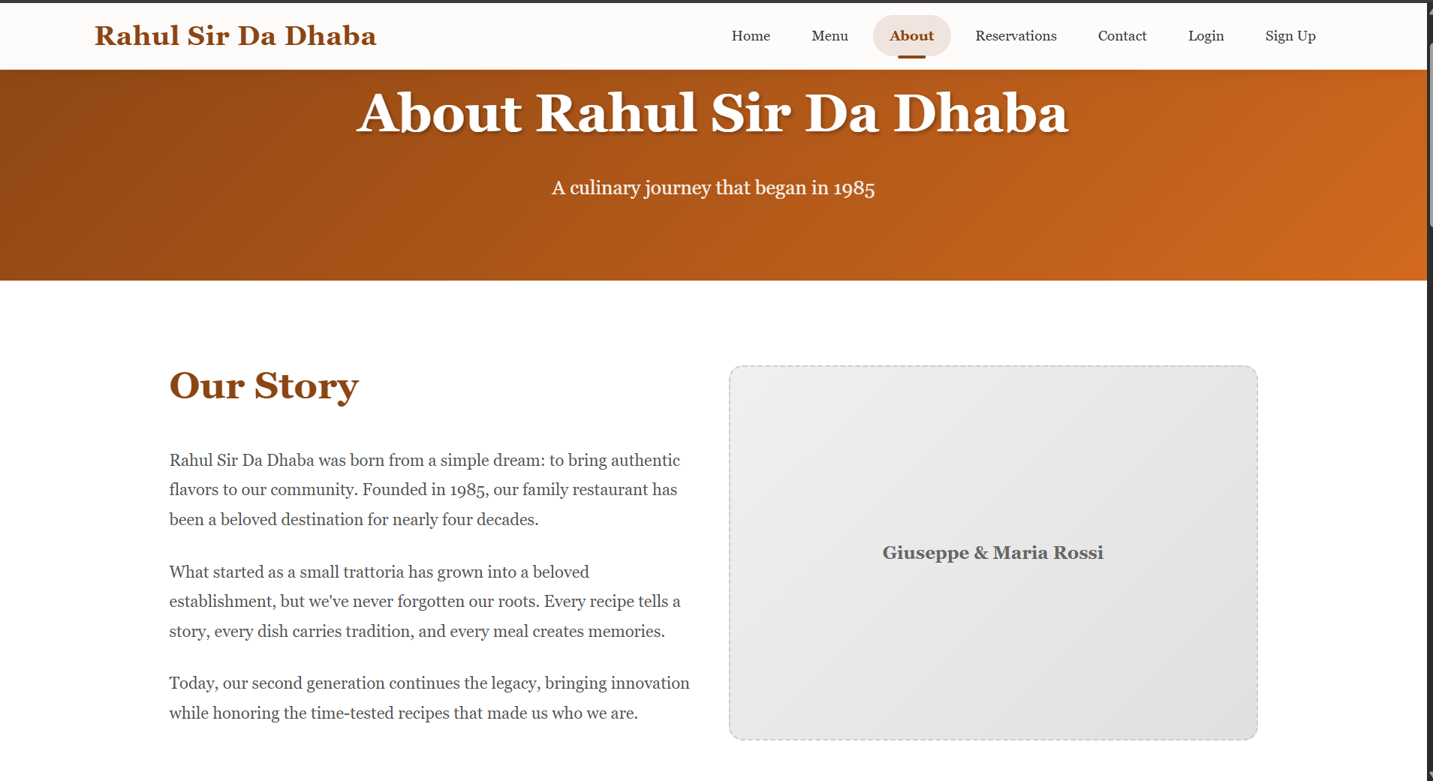

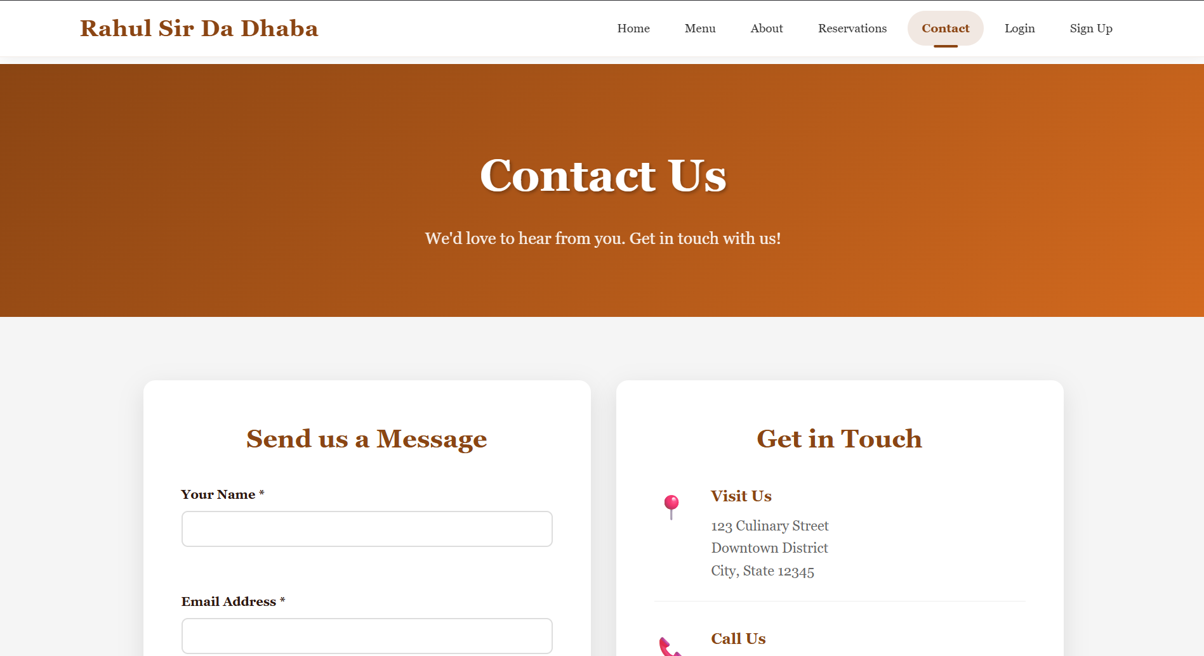

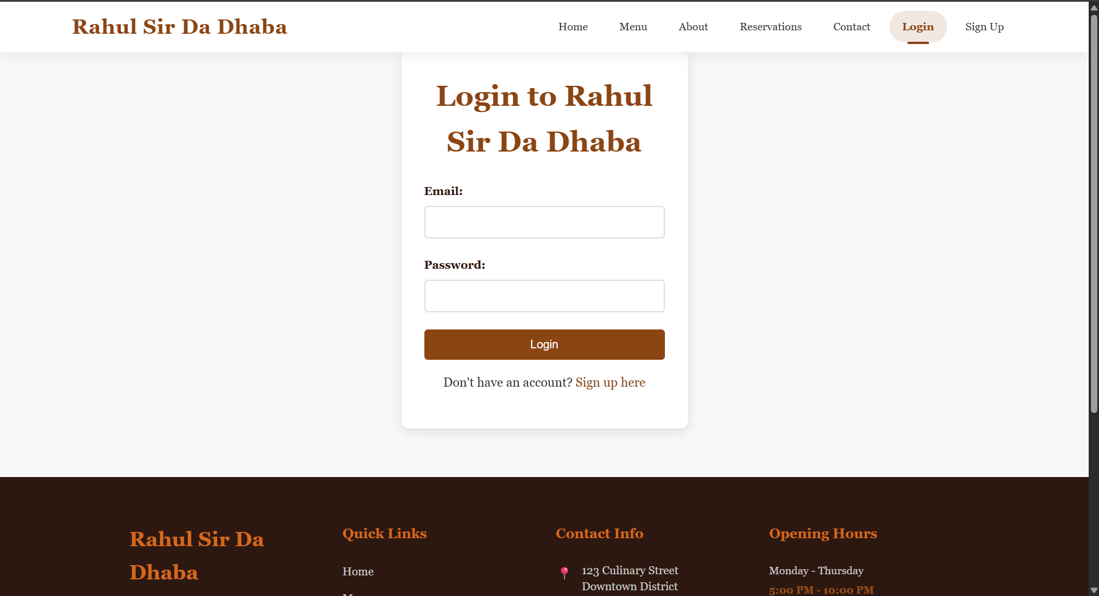

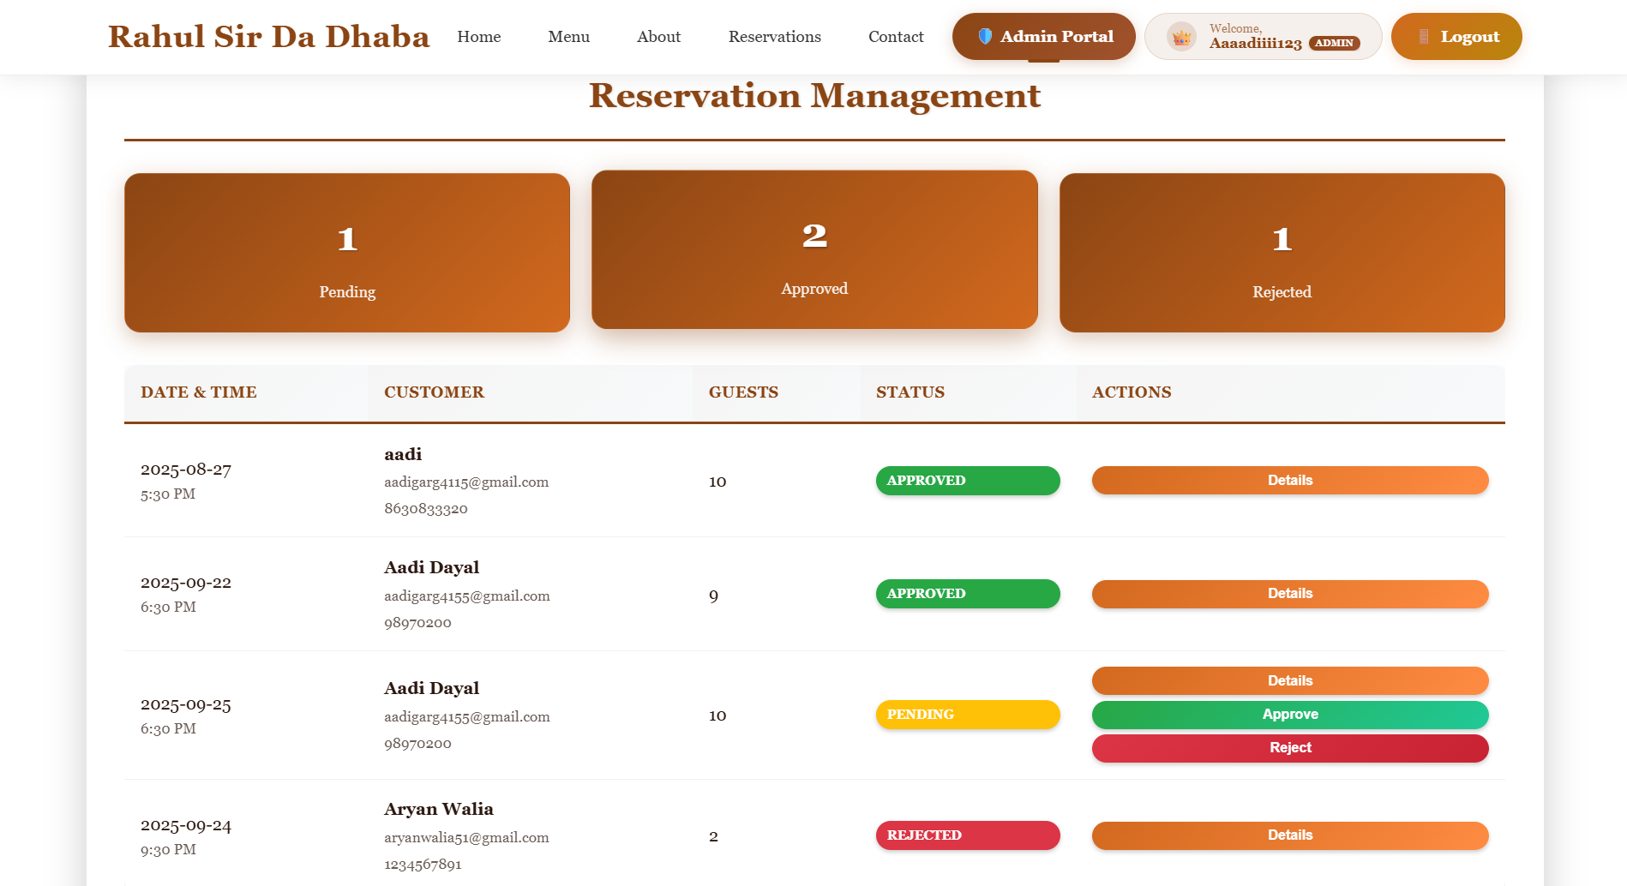

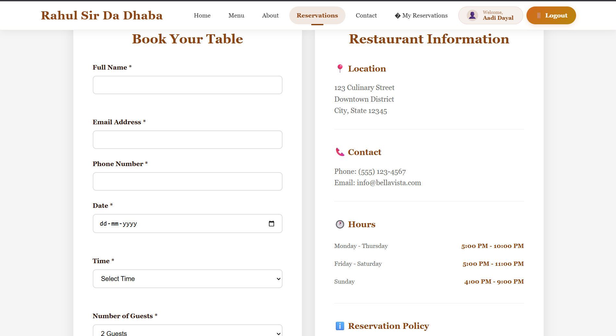

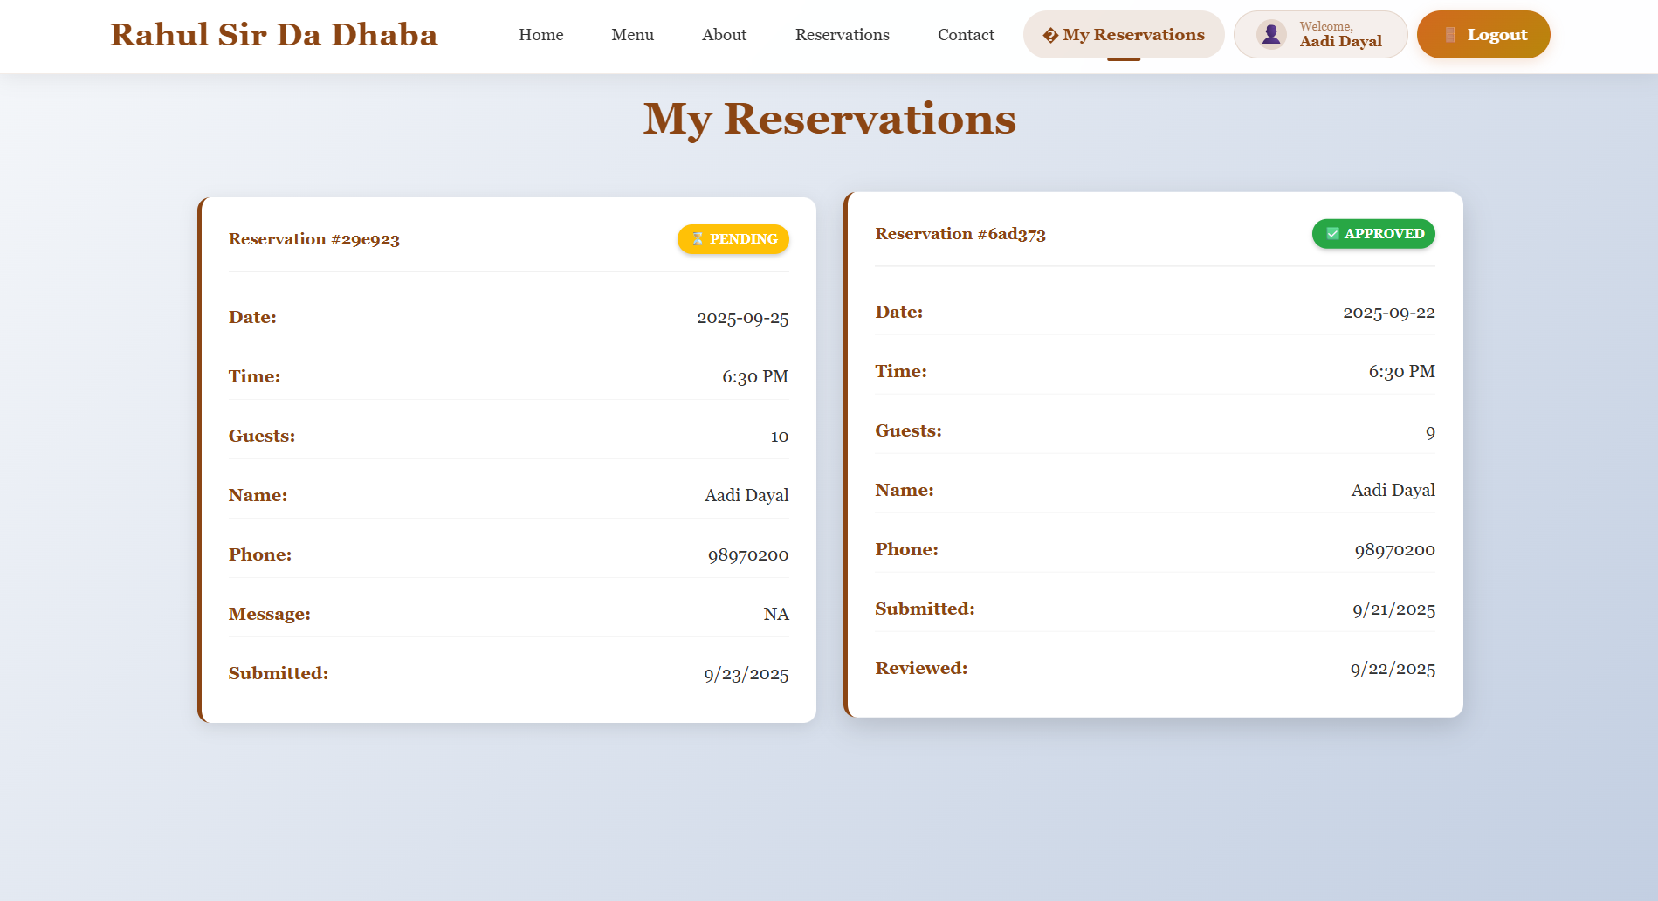

## REFERENCES

* MongoDB Documentation Team. (2024). "MongoDB Manual - Document Database." MongoDB Inc. Available: <https://docs.mongodb.com/manual/>
* React Development Team. (2024). "React - A JavaScript Library for Building User Interfaces." Facebook Inc. Available: <https://reactjs.org/docs/getting-started.html>
* Node.js Foundation. (2024). "Node.js Documentation - JavaScript Runtime." Available: <https://nodejs.org/en/docs/>
* Express.js Team. (2024). "Express.js - Fast, Unopinionated, Minimalist Web Framework for Node.js." Available: <https://expressjs.com/>
* JSON Web Token. (2024). "JWT - JSON Web Tokens for Secure Authentication." Available: <https://jwt.io/introduction/>